California State Polytechnic University, Pomona

Lab 1: 2x1 Multiplexer

Group F:

Danny Manzo, Bronco ID: 014451190

Maher Mateen, Bronco ID: 013891189

ECE 3101L – Signals and Systems Laboratory

Professor Mohamed Aly

13 June 2022

1. **How a Multiplexer Works:**

A multiplexer is a circuit that selects binary inputs from one of the inputs to the output. A mux contains a select input which chooses one of the many inputs. No matter how many inputs a multiplexer has, there will always be one output. A multiplexer exists because it helps reduce the complexity of a circuit since a multiplexer has gates and it helps reduce cost.

1. **How We Coded It:**

To code the 2x1 multiplexer to have 4-bit inputs and a 4-bit output, we specified the I/O ports in our design source file when defining the module. By checking the Bus column in the I/O Port Definitions, we were able to make the 2 inputs, “a” and “b”, and 1 output, “c”, be 4-bits long by specifying the most significant bit (MSB) to be bit 3 and the least significant bit (LSB) to be bit 0. A third input, “Sel”, was made to be 1 bit long to act as our select input of our 2x1 multiplexer. Next, we used behavioral modeling to create our 2x1 multiplexer, using an always block, with the events it is waiting for specified as an argument. Within the always block, we checked whether the select input, “Sel”, changed using an if else statement since it could only have 2 possible values, 1(true) or 0(false). When the select input has a binary value of 1, we chose input b to be our output, while when the select input has a binary value of 0, we chose input a to be our output.

1. **Vivado Data Collection:**

In Vivado, after running the synthesis and report utilization, we found that the number of look-up tables (LUTs) used was 2 and 13 input/output bits (IOB). The total power of the multiplexer was also reported to be 4.243 W.

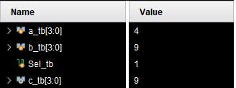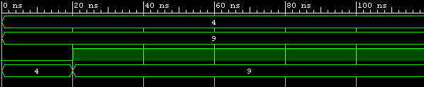

Figure 1: Testbench Results

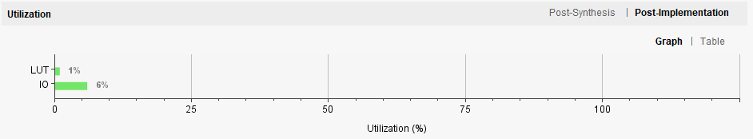

Figure 2: Resource Utilization Graph

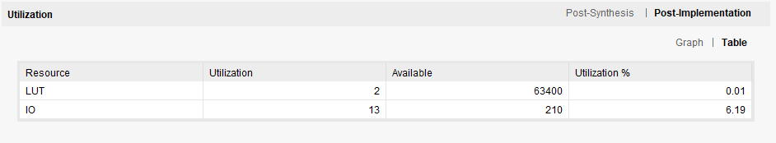

Figure 3: Resource Utilization Table

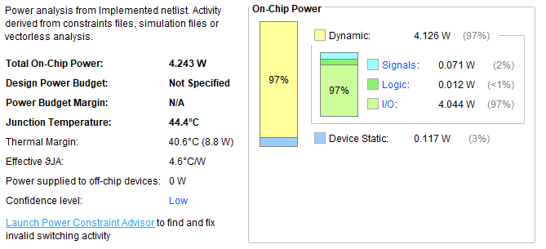

Figure 4: Power Usage